ASSIGNMENT_1

NAME: SHAIK ASHA MUSKAN

EMAIL ID: [ashiasha2409@gmail.com](mailto:ashiasha2409@gmail.com)

Phone: 9346526608

Roll no: 20NN1A1257

College Name: VIGNAN’S NIRULA INSITITUE OF TECHNOLOGY AND SCIENCE FOR

WOMEN, GUNTUR

SOURCE CODE:

HTML:

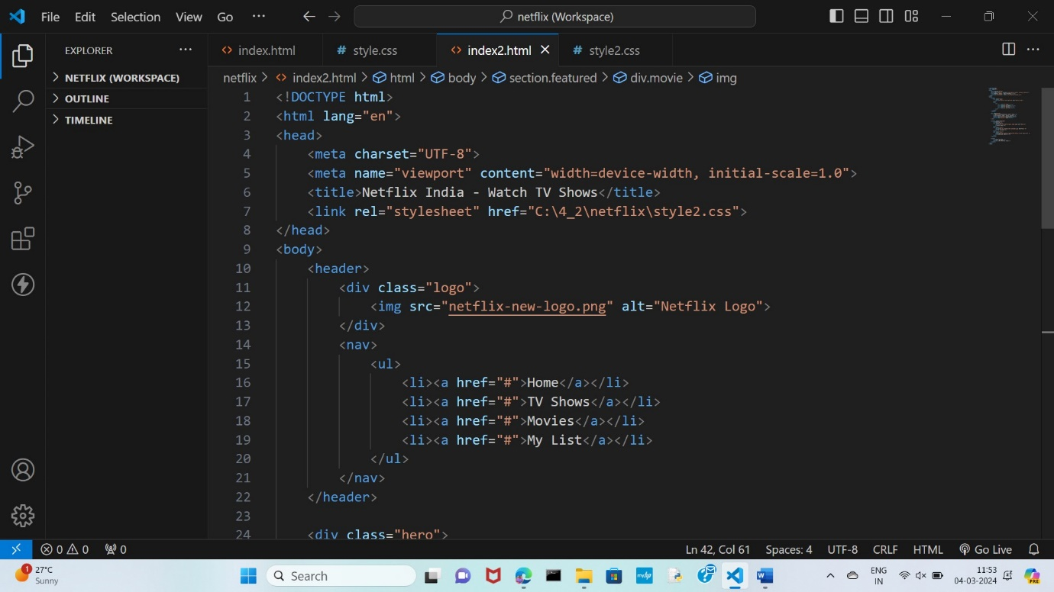

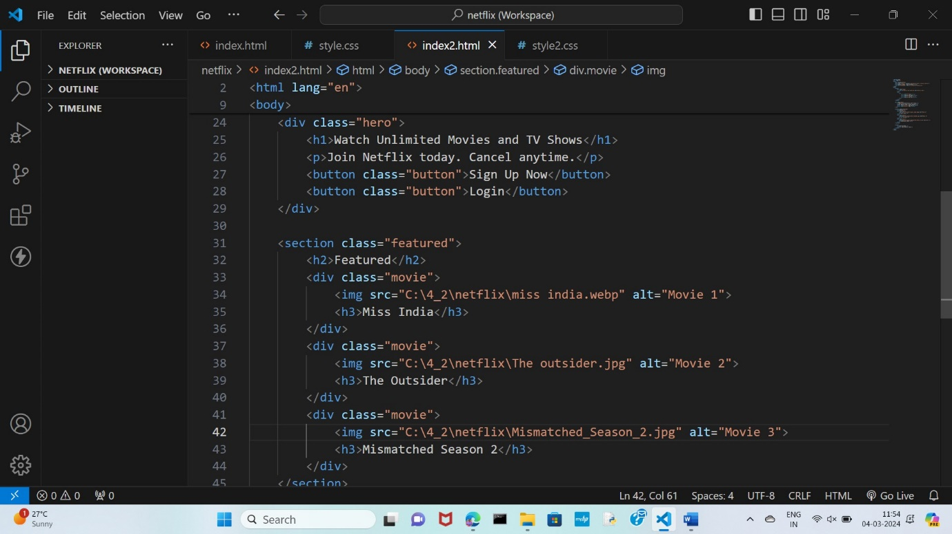

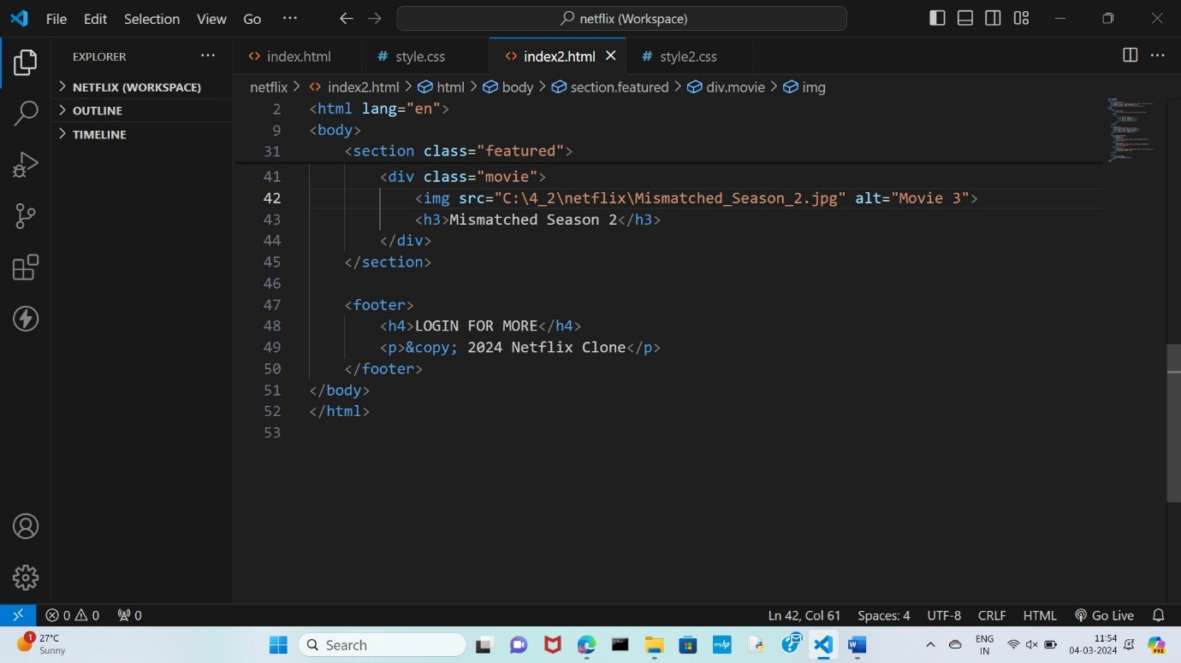

CSS – SOURCE CODE:

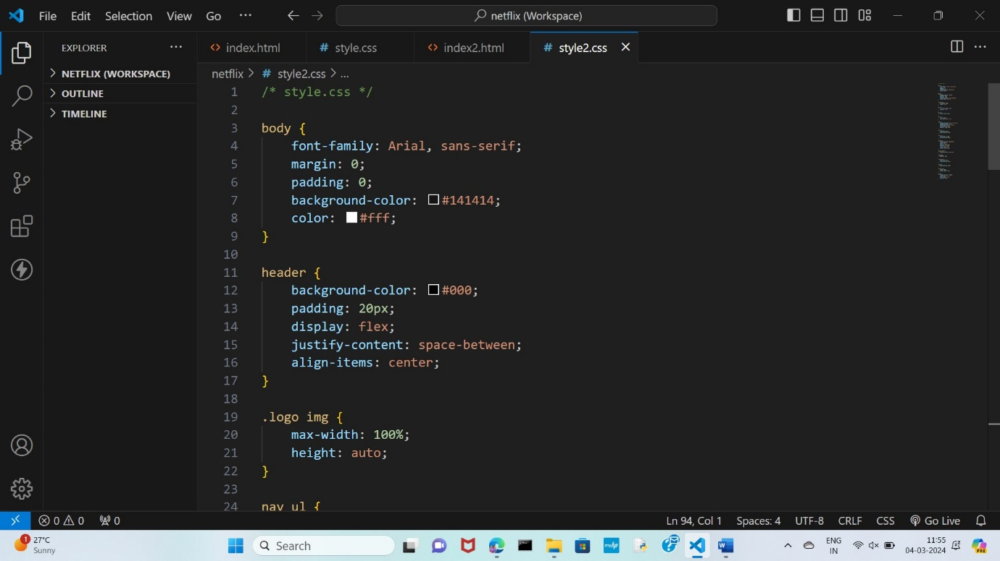

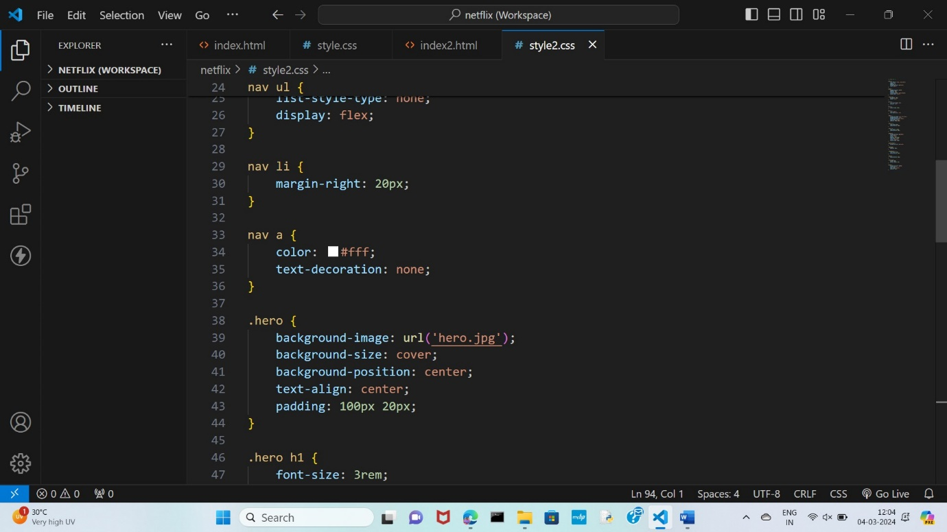

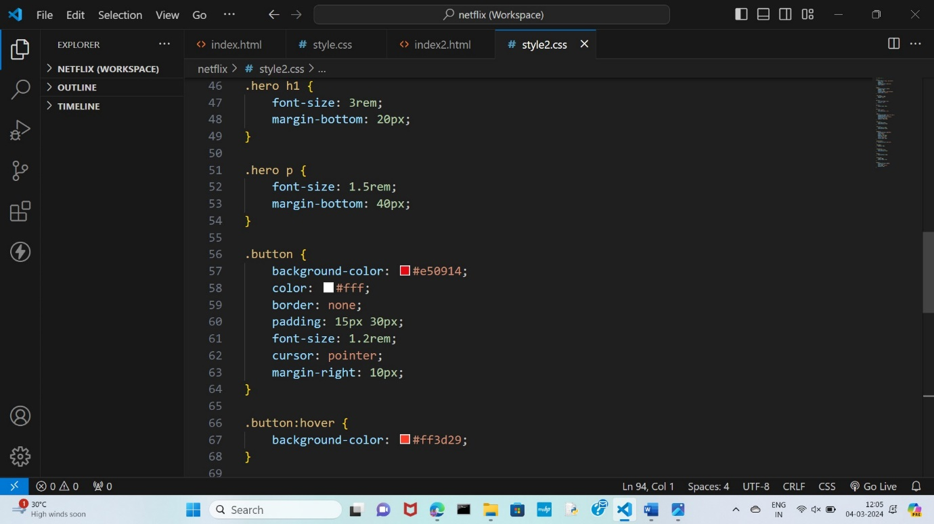

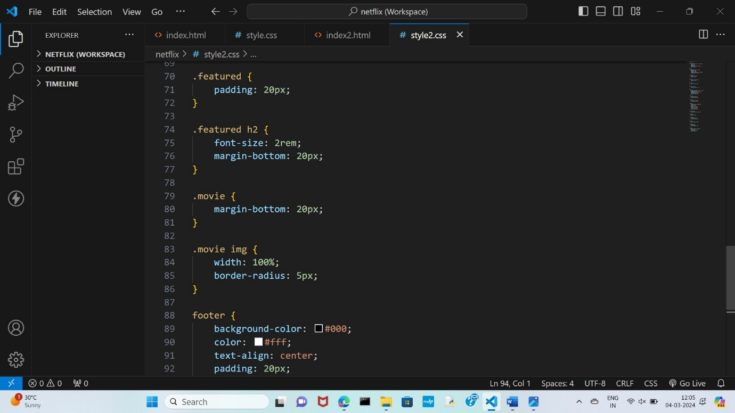

OUTPUT:







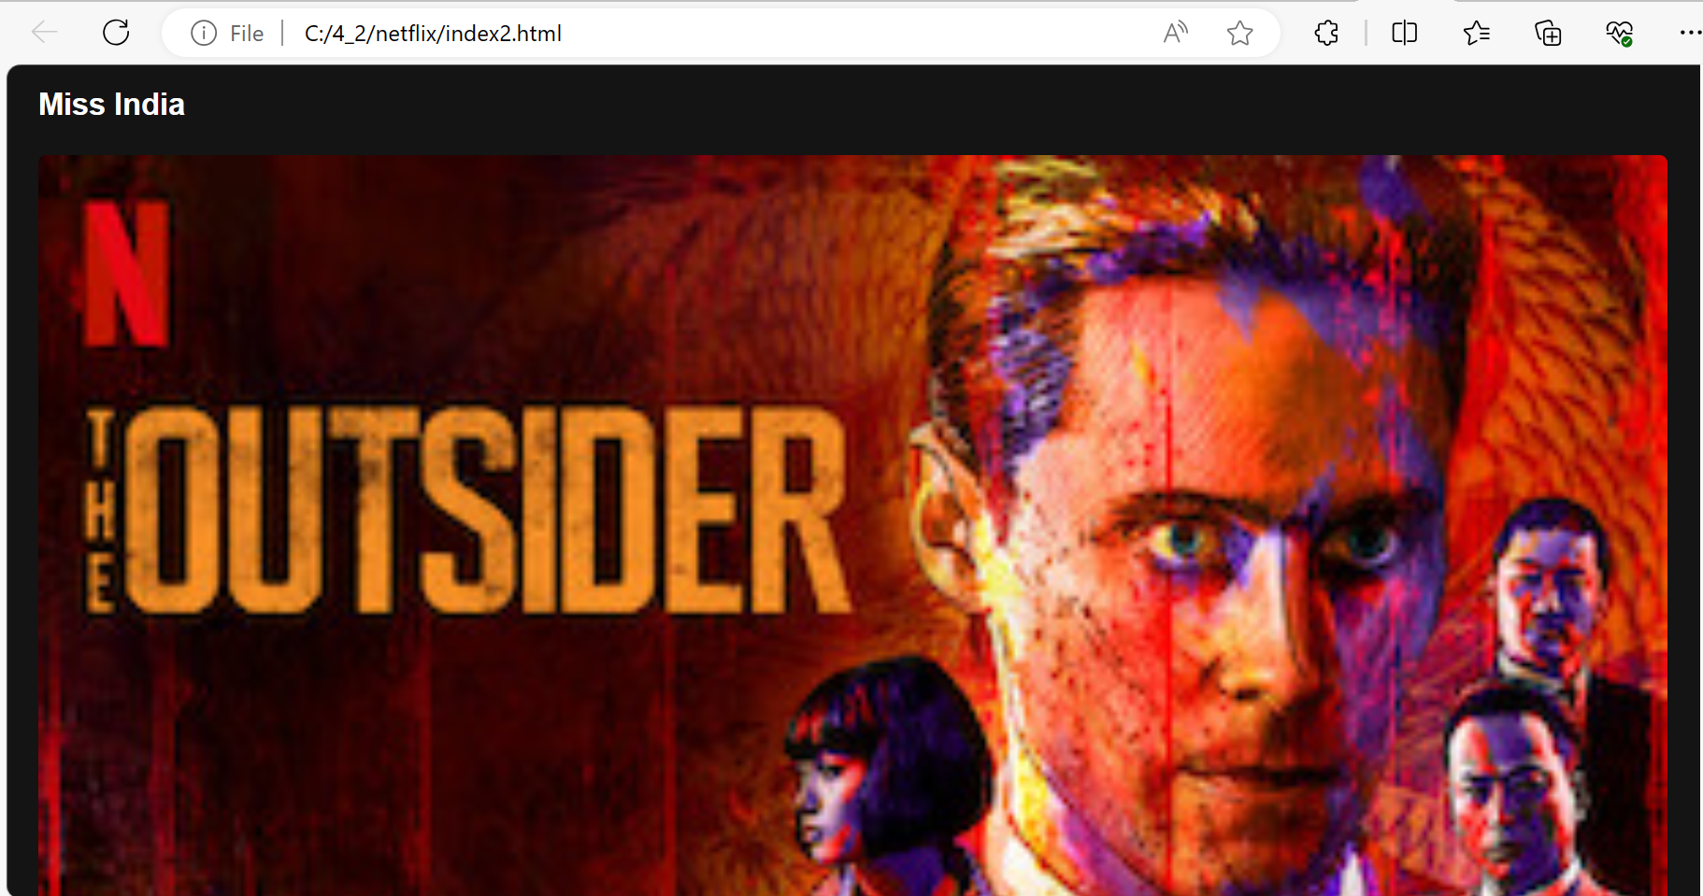





GITHUB REPOSITORY:

https://github.com/asha2409/NETFLIX